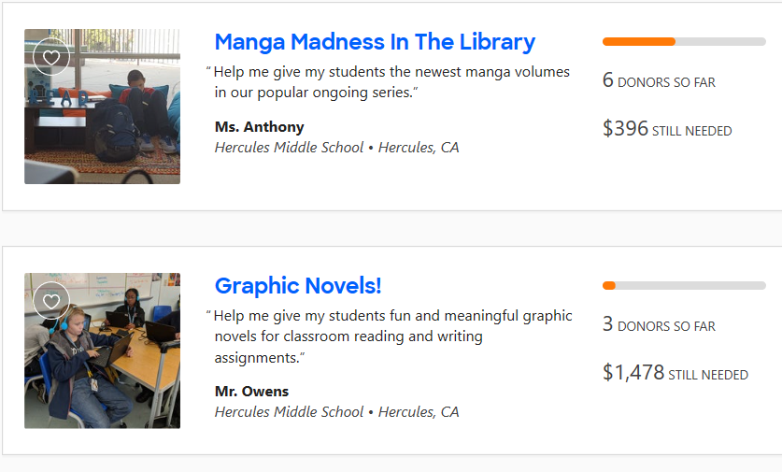
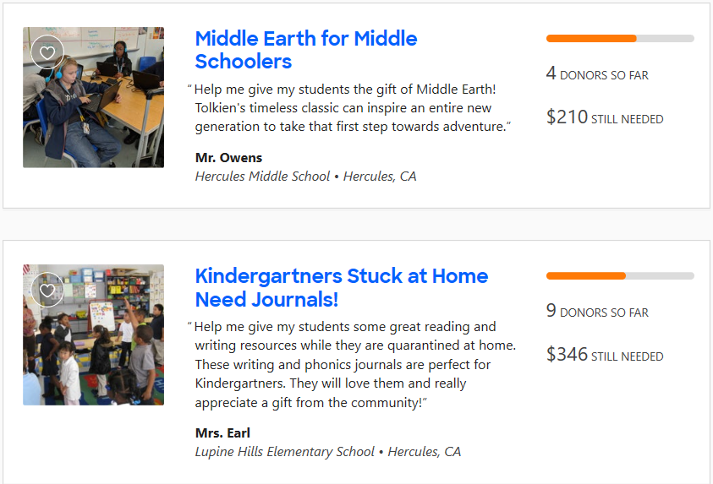

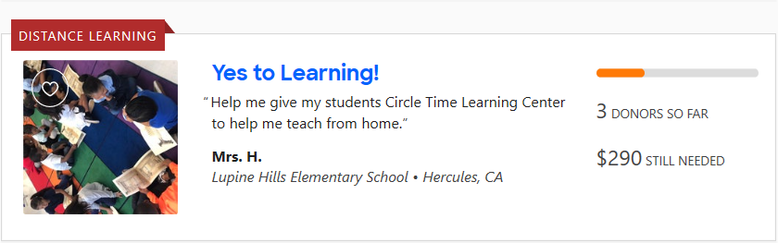

Project expiration dates:
Manga Madness – June 24
Graphic Novels – July 2
Middle Earth – July 4
Kindergartners Stuck at Home – August 3
Yes to Learning – September 4

